High Jump

Method | Age Groups | Rules
Scissors | U9-U10 | Athletes must;  - take off from one foot  - clear the bar in a predominately vertical position and  - first contact made on the landing area must be made by one or both feet
Flop | U11-U16 | Athletes must;  - take off from one foot  - clear the bar and land in any way they choose

Attempts:
Athletes will be allowed:
- 3 attempts at the height they enter the competition
- 2 attempts at all subsequent heights
- Any athlete attempting to break or equal a centre record will receive 3 attempts, including all subsequent heights

An athlete is out of the competition once they have failed either 3 consecutive attempts at first height or 2 consecutive attempts on any subsequent height.
Failures Include:
- Knocking the bar from the uprights
- Touching any part of the mat or upright when not jumping over the bar
- For U9-U10 not landing on feet, or not clearing the bar in a vertical position

Starting Heights
AGE | U9 | U10 | U11 | U12 | U13 | U14 | U15 | U16
GIRLS | 0.65 | 0.70 | 0.85 | 0.95 | 1.00 | 1.05 | 1.10 | 1.15
BOYS | 0.70 | 0.80 | 0.95 | 1.05 | 1.10 | 1.15 | 1.20 | 1.25

At the end of the round the bar should be raised in 5cm increments. When there are 4 or less athletes remaining, the increments will be 2cms.

Officials Required
- Two officials at the uprights: to return the crossbar to the supports
- One official to judge the jump and record the result

Measuring the Crossbar Height:
The height is checked with the measuring stick, taking the distance from the ground to the lowest point of the cross bar, usually in the middle.

Long Jump

Age Groups | Take-off
U6-U8 | Large mat (1.00m x 1.22m) covered in wet sand
U9-U10 | Small mat (0.5m x 1.22m) covered in wet sand
U11-U16 | White painted take-off board (black section is no-jump)

***Where mats are in use (U6-U10) it should be setback 0.50m from the front edge of the pit***

Successful attempts
- Using mat – foot cannot cross the edge of the mat closest to the pit
- No mat – foot cannot go over the white section of the board (if foot touches or goes over black strip this is considered a no jump)

Measuring an attempt:

Where a mat is in use (U6-U10)
- The spiker will mark the closest break in the sand to the front of the pit
- The marshal will measure from the footprint on the mat closest the sand pit

Where a board is in use (U11-U16)
- The spiker will mark the closest break in the sand to the front of the pit
- The marshal will measure perpendicular from the spiker’s point to the edge of the board closest to the sand pit
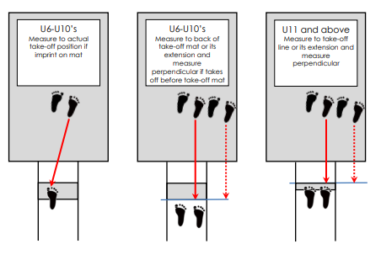
Officials Required
- Marshal: to rule on each jump and measure distance of each attempt
- Spiker: to mark with a spike the closest break in the sand to the front edge of the pit
- Raker: to rake the pit before each attempt
- Recorder: to record the result of each attempt

Triple Jump

Age Groups | Take-off
U11-U16 | White painted take-off lines

Essendon Little Athletics have 8 take-off boards, 4, 5, 6, 7, 8, 9, 11 & 13 metres

Successful Attempt
Where an athlete;
- Begins their hop on or before their nominated metre board
- Completes sequence of a Hop-Step-Jump, landing in the sand pit

Measuring an attempt:
- The spiker will mark the closest break in the sand to the front of the pit
- The marshal will measure perpendicular from the spiker’s point to the edge of the nominated line marking closest to the sand pit, to the nearest full centre metre
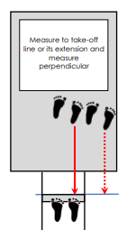

Officials Required
- Marshal: to rule on each jump and measure distance of each attempt
- Spiker: to mark with a spike the closest break in the sand to the front edge of the pit
- Raker: to rake the pit before each attempt
- Recorder: to record the result of each attempt

Discus

Age Groups | Weight
U6-U7 | 350g
U8-U11 | 500g
U12-U13 | 750g
U14-U16 | 1kg

Successful Attempt
Where an athlete
- Begins and finishes their attempt from within the throwing circle
- Does not touch any part outside the circle during the attempt
- The throw lands within the designated landing sector
- Leaves the circle once via the rear half after the discus has landed
***Note there is no required technique for throwing of the discus***

Measuring an attempt:
- The spiker will mark the point where the discus first lands
- The marshal will pull the tape to the middle of the circle and measure from the point the tape crosses the edge of the circle, to the nearest full centimetre

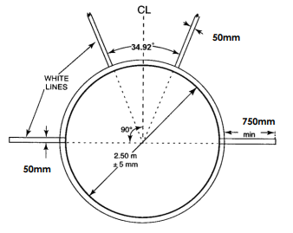

Officials Required
- Marshal: to rule on throw and measure distance of each attempt
- Spiker: to mark with a spike the point where the discus first lands
- Recorder: to record the result of each attempt

Shot Put

Age Groups | Weight
U6 - U7 | 1kg
U8 | 1.5kg
U9 - U12 | 2kg
U13G - U16G | 3kg
U13B - U14B | 3kg
U15B - U16B | 4kg

Successful Attempt
Where an athlete
- Begins and finishes their attempt from within the throwing circle
- Does not touch any part outside the circle during an attempt
- Must start with the shot put touching the neck and release in a pushing motion only
- The put lands within the designated landing sector
- Leaves the circle via the rear half after the shot put has landed

Measuring an attempt:
- The spiker will mark the point where the put first lands
- The marshal will pull the tape to the middle of the circle and measure from the point the tape crosses the edge of the circle, to the nearest full centimetre

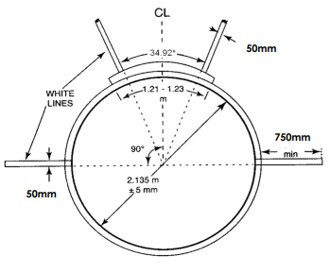

Officials Required
- Marshal: to rule on attempt and measure distance of each attempt.
- Spiker: to mark with a spike the point where the discus first lands
- Recorder: To record the result of each attempt

Javelin

Age Groups | Weight
U11B - U12B & U11G – U14G | 400g
U15G - U16G | 500g
U13B - U14B | 600g
U15B - U16B | 700g

Successful Attempt
Where an athlete
- Begins and finishes their attempt from within the runway and doesn’t cross the white foul line
- The javelin lands within the designated landing sector
- The leading point tip of the javelin must make first contact with the ground
- Leaves the runway without cross the foul line

Measuring an attempt:
- The spiker will mark the point where the leading point of the javelin first lands
- The marshal will pull the tape to the middle of the runway and measure from the point the tape crosses the edge of the foul line, to the nearest full centimetre

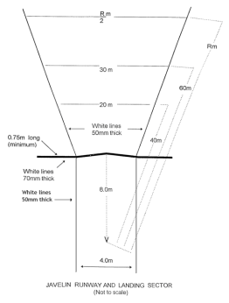
Officials Required
- Marshal: to rule on attempt and measure distance of each attempt
- Spiker: to mark with a spike the point where the Javelin first lands
- Recorder: to record the result of each attempt

